CURRICULUM-VITAE
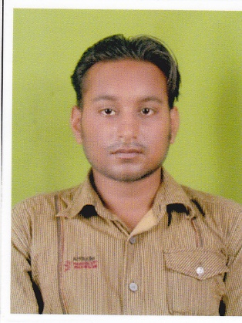
NAME- RAJESH KUMAR PATEL POST APPLIED FOR - MEDICAL LABORATORY TECHNICIAN Mobile:8280492353 , 9937186158 Email-ID : rajesh158patel@gmail.com

Career Objective
Keeping in view my academic knowledge, professional skills, personal strengths. I wish to start my carrier with entry level position, followed by best to the organization and grow with it to more responsible positions within 5 years.
Educational Qualification
COURSE | COLLEGE/SCHOOL | UNIVERSITY/BOARD | CGPA 7 MARKS (%)
10+ | New Orissa High School Gaibira (Subdega) | BSE (Orissa) | 51
12th | A.S. collage , Subdega | CHSE(Orissa) | 50
DMLT in  Cl. pathology | MTIMT , Angul | IM & TR Kolkata | 68

EXPERIENCE
- 10 years experience at Bharat Sevashram Sangha (Kurumkel Hospital) from October 2003 to December 2013.
- Now I am working in a dispensary of Thriveni Earthmovers Private Limited from January 2014 to till now.
Personal Skills
Sincere towards my work, Passionate, Punctual, Responsible, Disciplined, Good sense of hum our, Ability to tackle any risk successfully.
Personal Details
- Date of Birth : 12th June 1984
- Father’s Name : (Late) Debarchan Patel
- Permanent Address : At-Kurumkel Po-Kurumkel Via-Subdega Dist-Sundargarh (ODISHA) PIN-770014
- Present Address : C/O- Sushil Kumar Patel (Advocate)
At-Lacture Colony
Behind New District Judge Court
Po- OMP Line
Jharsuguda (ODISHA)
PIN - 768204
- Nationality : Indian
- Language Known : English, Hindi & Odia
- Hobbies : Listening Music
Declaration
I do hereby declare that the particulars of information and facts stated herein above are true, correct and complete to the best of my knowledge and belief.
DATE: / /201
PLACE: RAJESH KUMAR PATEL

